Student Name: Syed Aazmir Hussain
Student ID: 24K-0945
Teacher: Mr Mubashir
Course: DLD Lab
Lab No: 2

Post Lab Taks

- (A + B) (B + C)

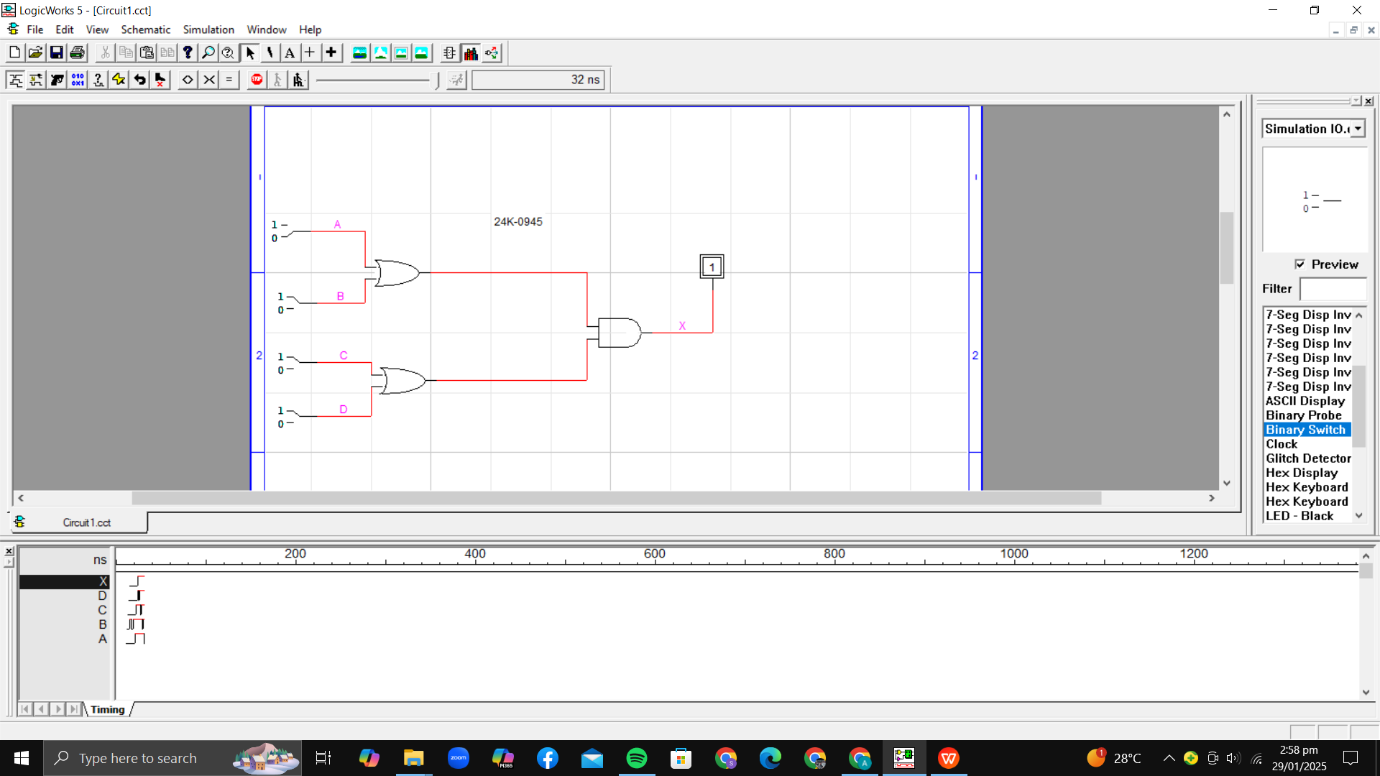

A | B | C | X
0 | 0 | 0 | 0
0 | 0 | 1 | 0
0 | 1 | 0 | 1
0 | 1 | 1 | 1
1 | 0 | 0 | 0
1 | 0 | 1 | 1
1 | 1 | 0 | 1
1 | 1 | 1 | 1

- (AB + C) D

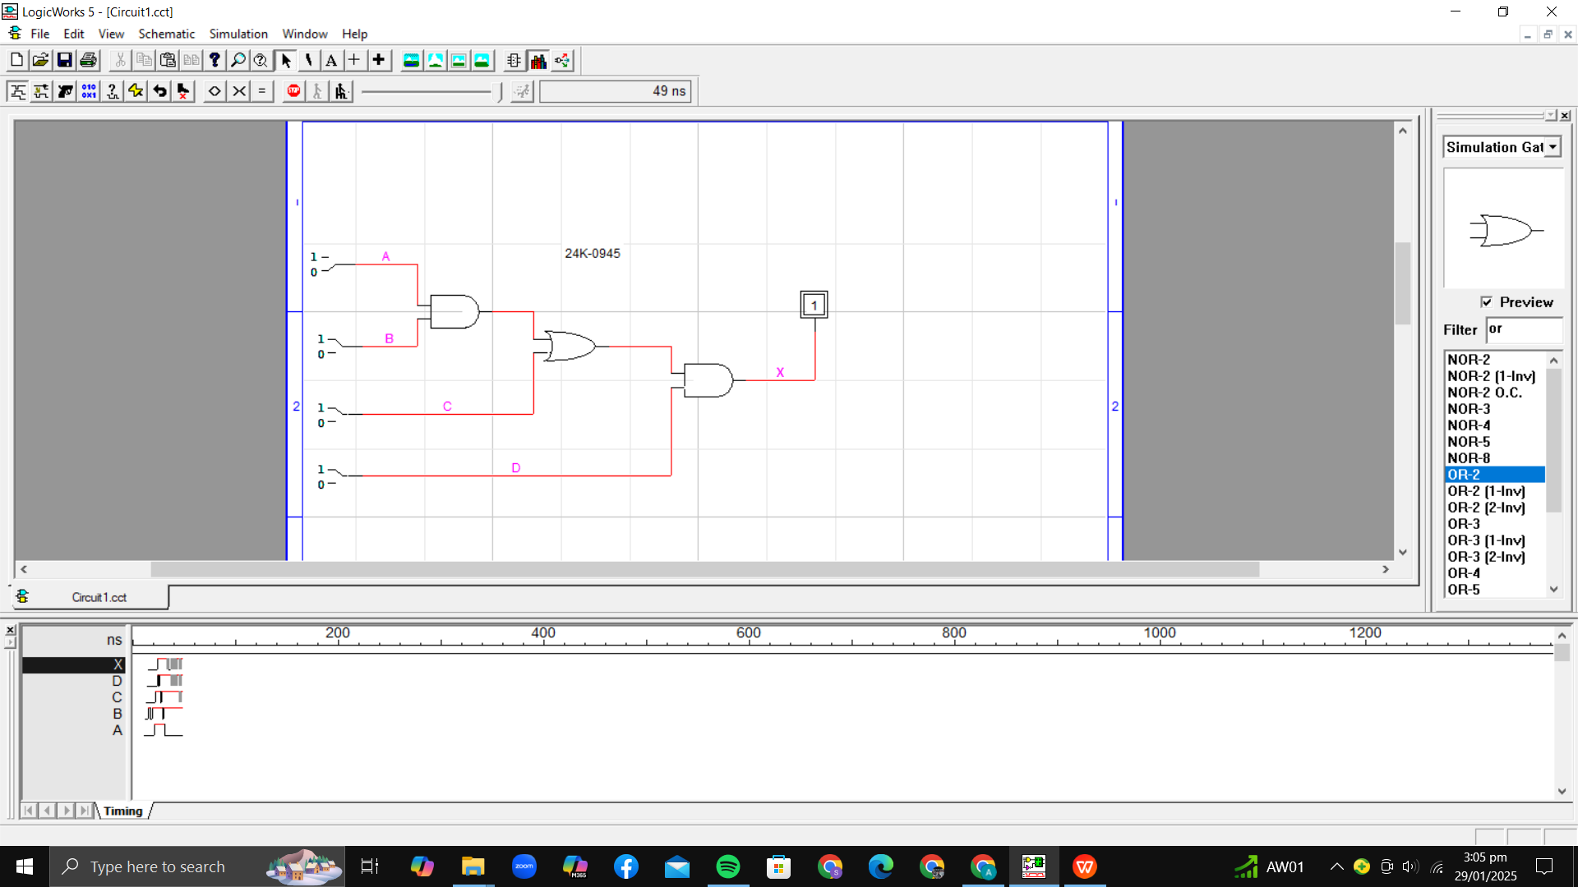

A | B | C | D | X
0 | 0 | 0 | 0 | 0
0 | 0 | 0 | 1 | 0
0 | 0 | 1 | 0 | 0
0 | 0 | 1 | 1 | 1
0 | 1 | 0 | 0 | 0
0 | 1 | 0 | 1 | 0
0 | 1 | 1 | 0 | 0
0 | 1 | 1 | 1 | 1
1 | 0 | 0 | 0 | 0
1 | 0 | 0 | 1 | 0
1 | 0 | 1 | 0 | 0
1 | 0 | 1 | 1 | 1
1 | 1 | 0 | 0 | 0
1 | 1 | 0 | 1 | 1
1 | 1 | 1 | 0 | 0
1 | 1 | 1 | 1 | 1

- ((A + B’C) (A+BC))’

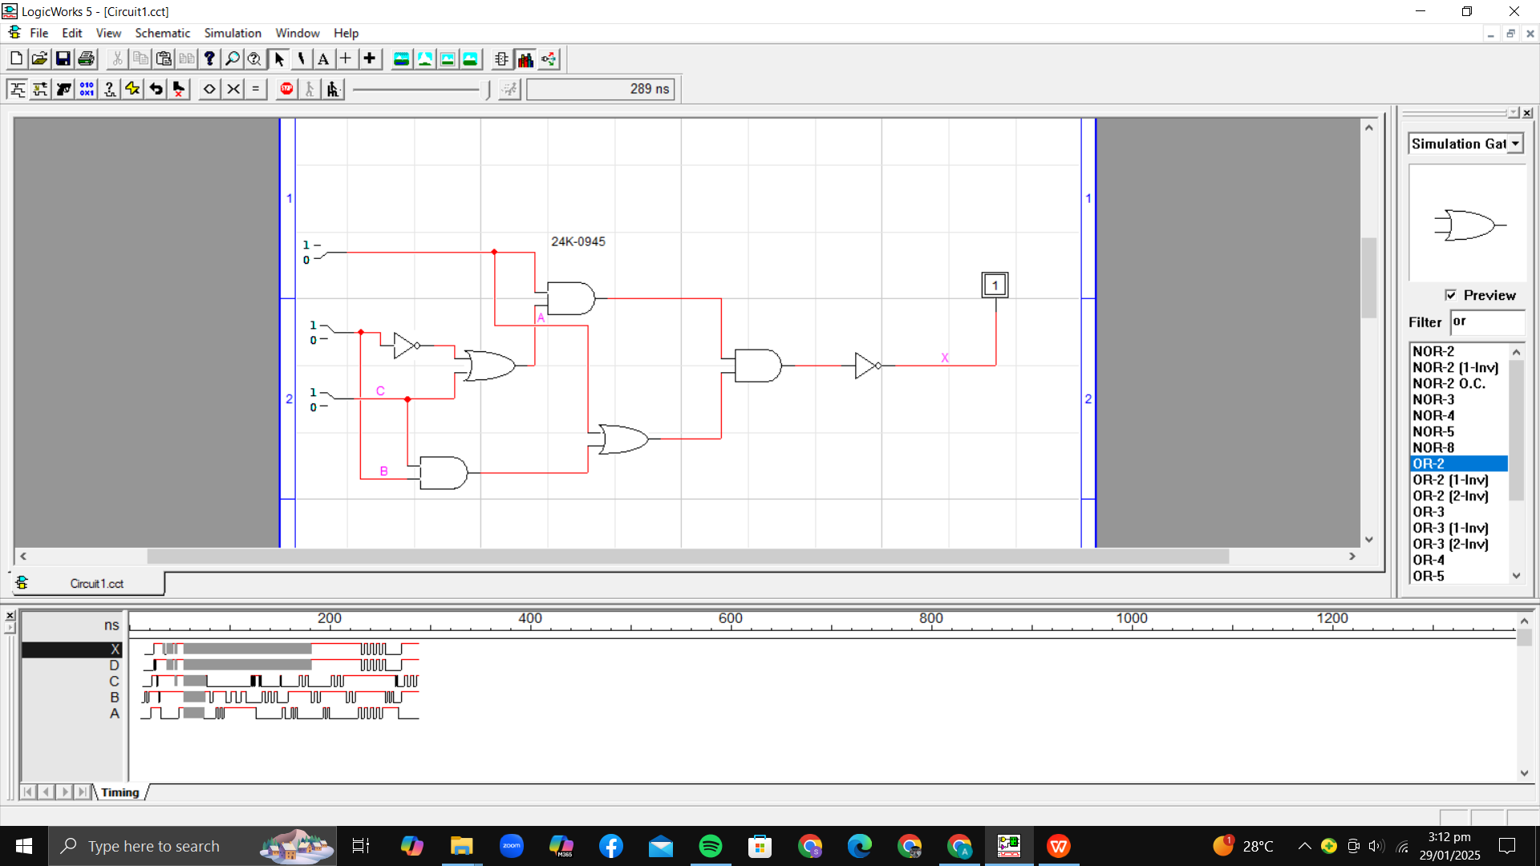

A | B | C | X
0 | 0 | 0 | 1
0 | 0 | 1 | 1
0 | 1 | 0 | 1
0 | 1 | 1 | 1
1 | 0 | 0 | 0
1 | 0 | 1 | 0
1 | 1 | 0 | 0
1 | 1 | 1 | 0

- A’BC + AB’C + ABC’ + (ABC)’

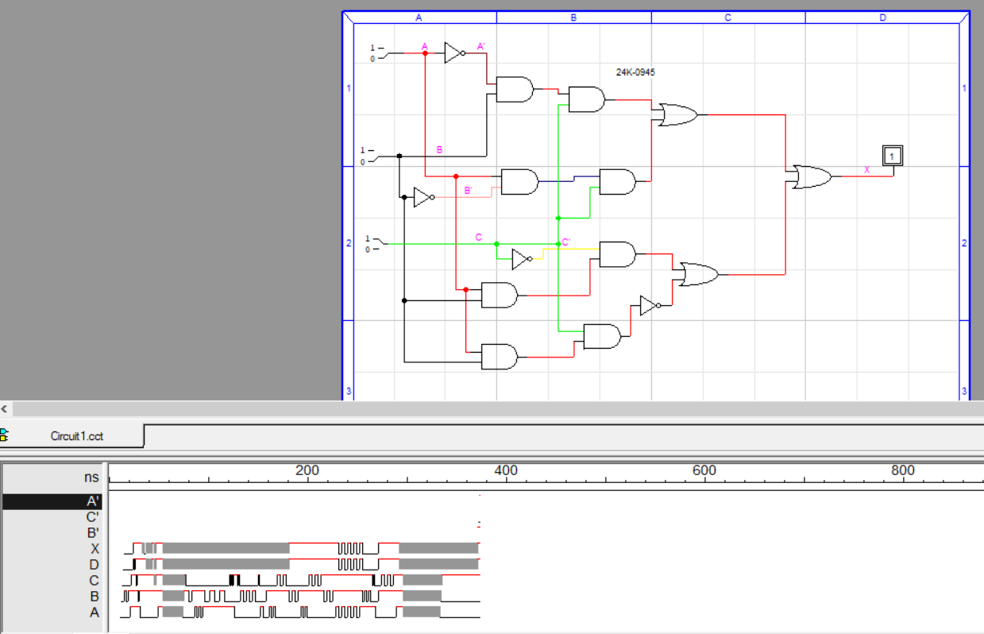

A | B | C | X
0 | 0 | 0 | 1
0 | 0 | 1 | 1
0 | 1 | 0 | 1
0 | 1 | 1 | 1
1 | 0 | 0 | 1
1 | 0 | 1 | 1
1 | 1 | 0 | 1
1 | 1 | 1 | 1

- (A’ + BC)’

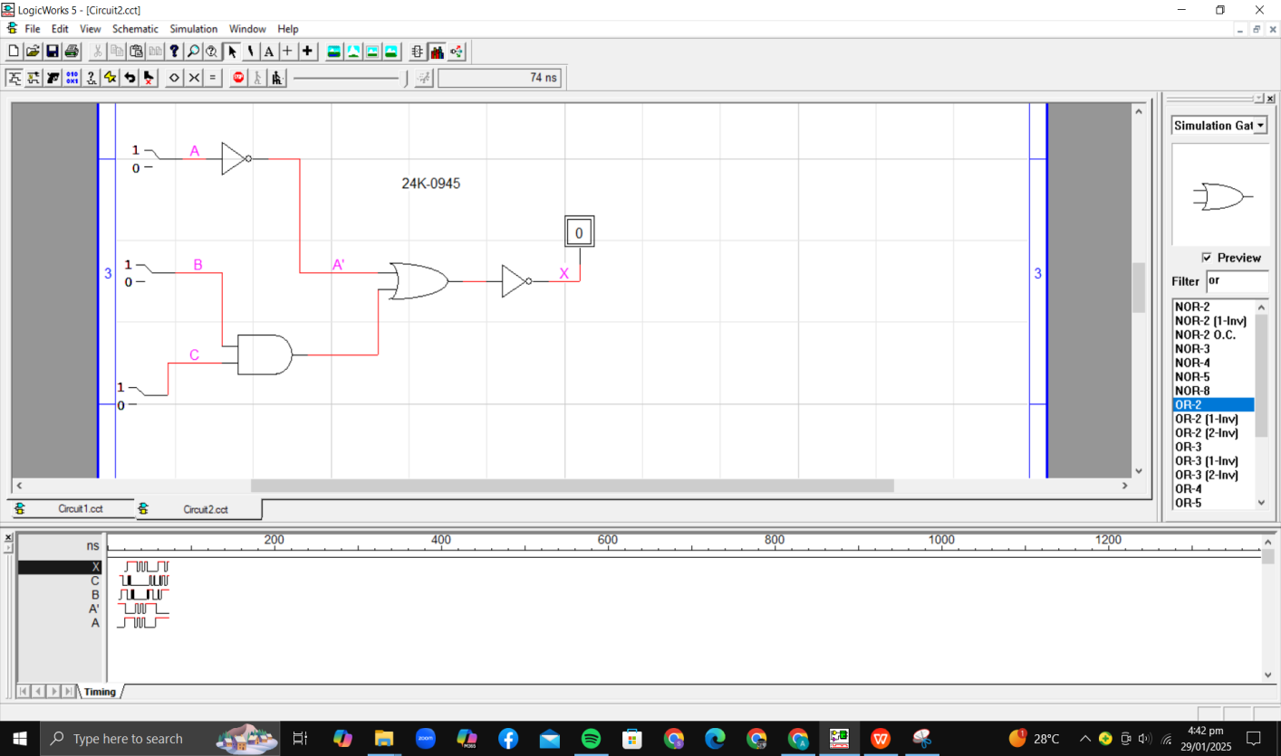

A | B | C | X
0 | 0 | 0 | 0
0 | 0 | 1 | 0
0 | 1 | 0 | 0
0 | 1 | 1 | 0
1 | 0 | 0 | 1
1 | 0 | 1 | 1
1 | 1 | 0 | 1
1 | 1 | 1 | 0

